DSA_PROBLEMS (18/11/2024)

1. Given an array, **arr[]**. Sort the array using bubble sort algorithm.

**Examples :**

**Input**: arr[] = [4, 1, 3, 9, 7]

**Output**: [1, 3, 4, 7, 9]

**Input**: arr[] = [10, 9, 8, 7, 6, 5, 4, 3, 2, 1]

**Output**: [1, 2, 3, 4, 5, 6, 7, 8, 9, 10]

**Worst-Case Time Complexity**: O(n2)

Code:

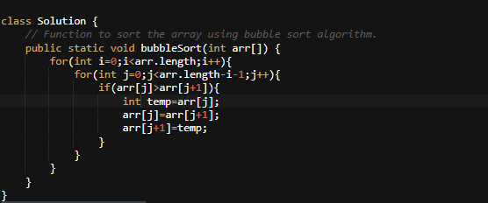

Output:

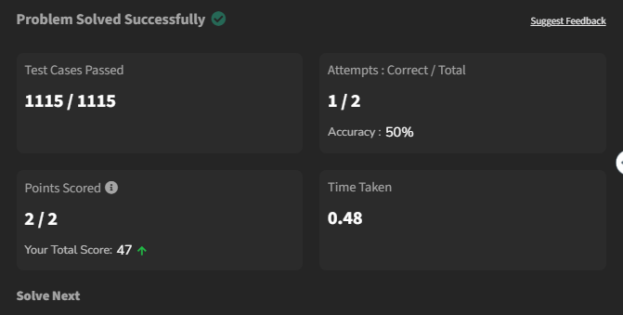

2. 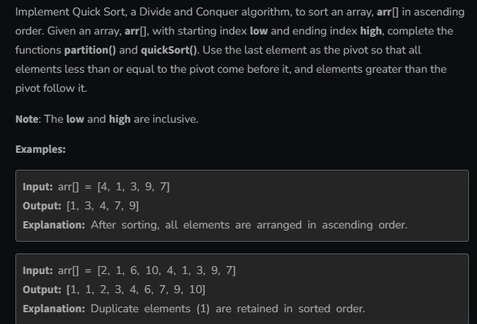

Code:

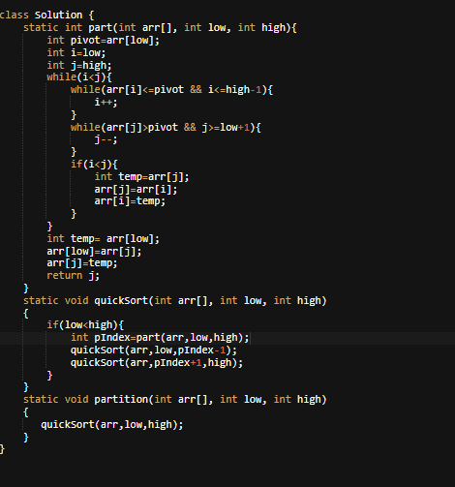

Output:

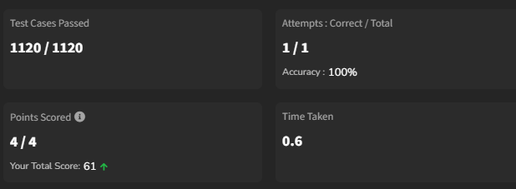

3. 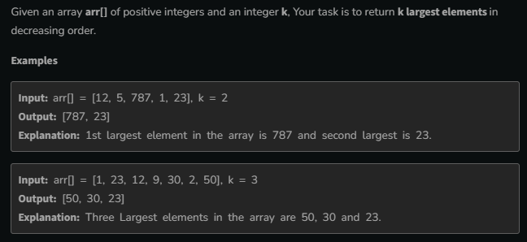

Code:

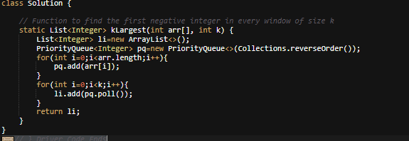

Output:

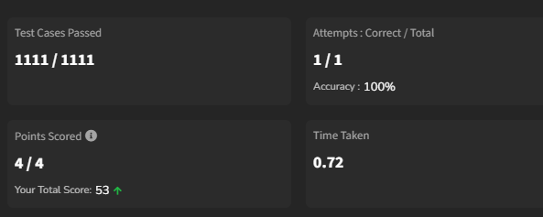

4. 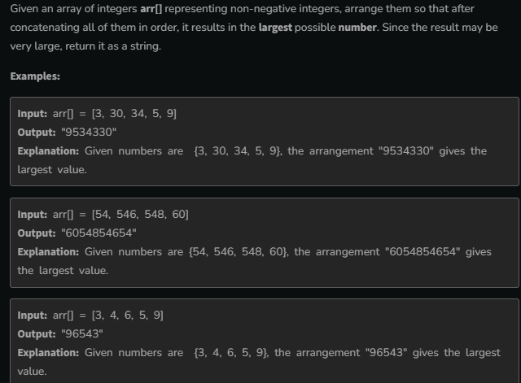

Code:

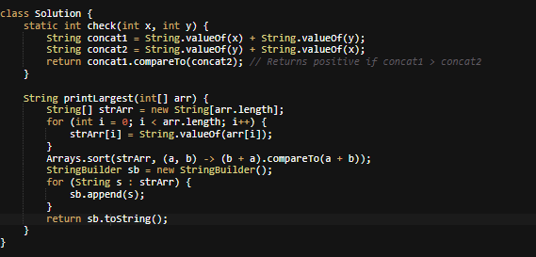

Output:

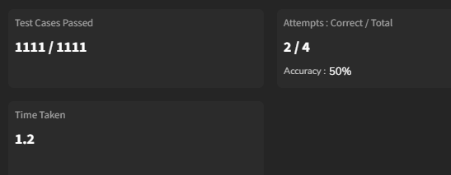

5. 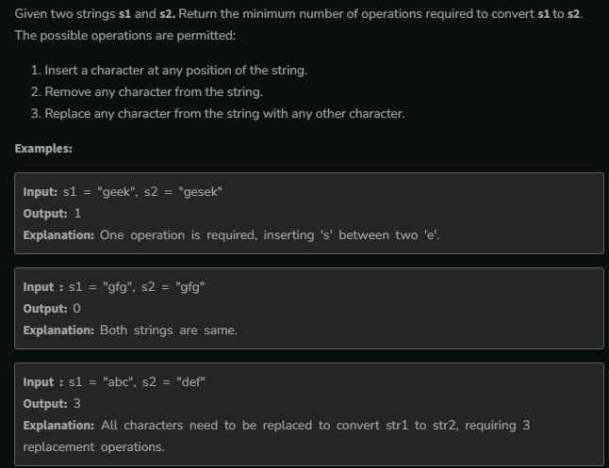

Code:

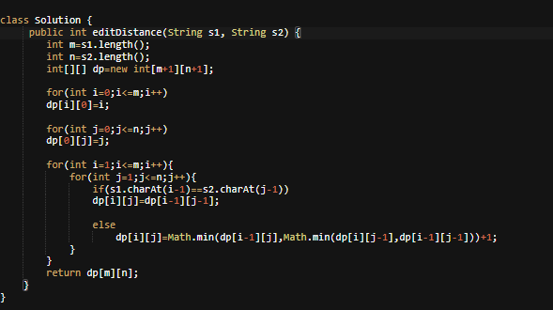

Output:

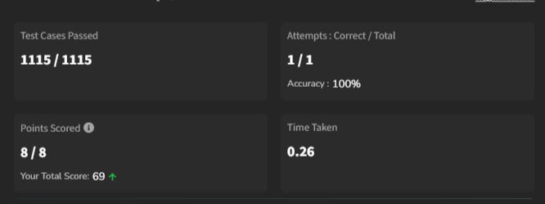

6. 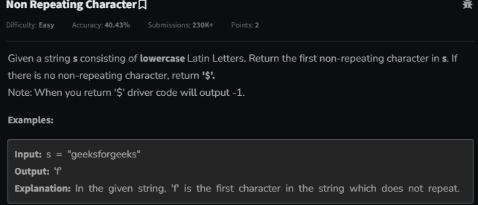

Code:

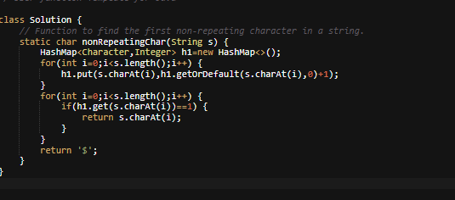

Output:

